IDEATION PHASE – DOCUMENT 2:
DEFINE PROBLEM STATEMENT
Date | 06 November 2025
Team ID | NM2025TMID06186
Project Name | Lease Management
Maximum Marks | 4 Marks

Title: Problem Definition for “Lease Management”

1. Objective
The objective of this document is to define the key problem faced in traditional lease handling, its causes, impact, and the technical justification for building a digital lease management solution using Salesforce.
The purpose is to convert an initial idea into a clearly structured problem statement that will guide the entire project lifecycle.

2. Context and Background
Lease agreements are commonly used across residential, commercial, and industrial sectors.
However, the current process of managing leases is mostly manual, paper-based, and prone to disputes.
Common issues include:
- Missed rent payment reminders
- Lack of centralized record storage
- Difficulty in tracking lease expirations
- Legal disputes due to unclear terms
- No digital record of tenant-landlord communication
Studies show that over 60% of property owners in India still use offline records and WhatsApp communication for managing tenants.
This results in errors, delayed payments, and lack of transparency between tenants, landlords, and property managers.

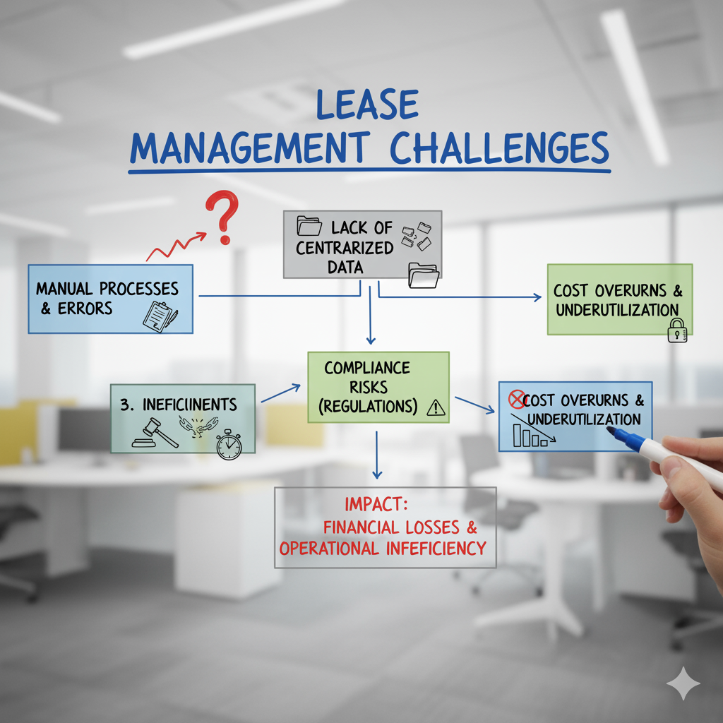

3. Problem Observation
Based on field interviews with property owners, tenants, and real estate agents, the following issues were identified:
Issue | Observation
Manual Documentation | Lease contracts stored as physical papers or scattered PDFs
No Auto-Reminders | Payments and renewal alerts not automated
Lack of Transparency | Tenants and owners do not share a unified platform
Dispute Handling | No evidence-based record of communication & payments
Expiry & Renewal Chaos | Owners forget to renew leases on time, causing legal issues

These issues indicate the need for a centralized digital lease management system that automates workflows and keeps all stakeholders connected.

4. Core Problem Statement
“There is no unified and automated digital platform to manage lease agreements, track payments, handle communication, and ensure timely renewals, leading to disputes, late payments, and record mismanagement.”

5. Project Goals
The Lease Management project aims to:
- Digitize lease agreements and store them in a secure cloud database.
- Automate rent reminders, lease expiry alerts, and payment status notifications.
- Enable tenant-owner communication through a centralized portal.
- Provide dashboards for rent tracking, overdue status, and renewal plans.
- Reduce legal disputes through transparent record-keeping.

6. Scope and Constraints
In-Scope | Out-of-Scope | Constraints
Lease creation & tracking | Legal approval of contracts | Internet access required
Auto reminders for rent & renewals | Payment gateway integration | Dependence on tenant response
Tenant–owner communication logs | AI-based rent prediction | Limited digital literacy for few landlords
Dashboard & reporting | Multi-country lease compliance | Data privacy policies

7. Technical Relevance
Salesforce is chosen due to:
- Secure cloud storage
- Low-code automation (Flow, Validation Rules, Triggers)
- Role-based access for Tenant, Owner, Admin
- Dashboard + Reports for monitoring

Key Salesforce components:
- Custom Objects: Lease, Property, Tenant, Payment
- Flows: Auto reminders for rent & expiry
- Reports: Monthly rent summary, overdue payments
- Email Alerts & Notifications: For both parties

8. Success Criteria
KPI | Target | Evaluation Method
Late Payment Reduction | 70% decrease in rent delay | Payment logs
Renewal Efficiency | 100% on-time renewals | System alerts
User Adoption | 85% tenant login rate | Login analytics
Dispute Reduction | 60% fewer complaints | Support ticket data

9. Expected Impact
- Eliminates paper-based lease handling
- Reduces rent default cases
- Improves trust between tenants & owners
- Creates a legally reliable audit history
- Saves 40–60% time spent in manual follow-up

